# Green balcony

# Not having garden doesn’t prevent you from enjoying a connection to nature.

Simply create an outdoor oasis on your balcony instead .

Beautiful planting is good for the soul,you can eat what you plant ,have a clean air and can detract attention from even the blandest or most unsightly of views.

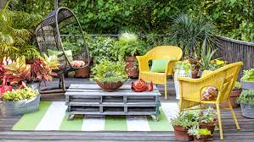So,green balcony is a web site that helps you to buy a plants from our store &help you to take care of it,or plant it by yourself with resources that will help you planting.

design

You can make use of many plants to improve the appearance of this space.

this site offer to user to sign in it to buy seeds and herbs to plant it and how to make it ,and sort of different plants and flowers and what is its benefit.

It can learn you how to plant and take care of it .